Title : Smart Health Consulting

Introduction: It might have happened so many times that someone needs doctor’s help immediately, but they are not available due to some reason. The ‘Smart Health Consulting System’ is an end user support and consultation project. Here I propose a system that allows users to get instant guidance on their health issues through an intelligent health care system. This system also provides to know their Body Mass Index(BMI), Basal Metabolism Rate(BMR) and their Diet chart.

**Using Tools:**1.Java programming language (javafx).

2. Cascading Style Sheets (CSS).

3.mysql-connector-java 5.1.38.

4.Eclipse SDK,JRE System Library[JavaSe-1.8].

6.JDK-8.

How to set up environment and to face problem: I would need at least JDK 8 installed in my system. Make sure that e (fx) clipse installation uses this JDK when anyone launch his Eclipse instance!

I face to problem to install JDK because first I installed below JDK-8.It must install JDK-8 or upper- version.

1.Download the latest release of the Eclipse 4.6 SDK.

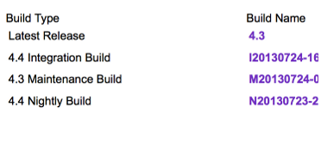

2. Fire up Eclipse IDE if it have been not done so already.

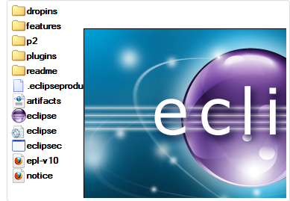

3. e(fx)clipse is an extension for Eclipse IDE which is delivered as a so called p2 repository. Extensions like this can be installed using the "Install New Software" wizard.

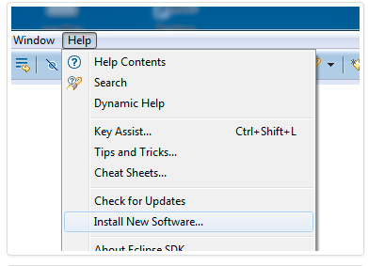

4. Eclipse does not know about the location of the e(fx)clipse p2 repository so it is needed to add the repository as a software site.

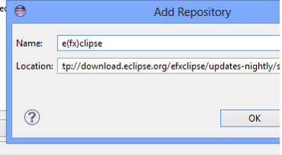

5.In the tree of installable features, check only the entry corresponding to release:

* e(fx)clipse - IDE

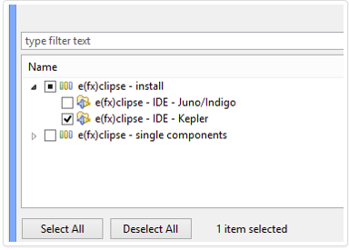

6. Go through the wizard and let p2 do its job.

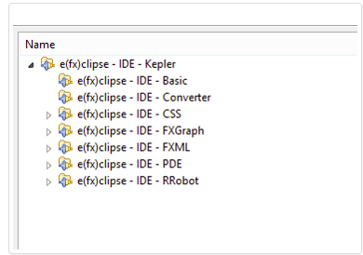

7. When requested, restart Eclipse.

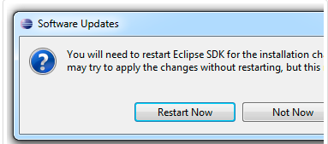

## The user want to do: The users can see in first window three Button – “Adminpanel”,

## “User” and “exit”. Here I created three Button by ‘Button b(object)=new Button(“name”) this by declaration. Everyone must import this header file import javafx. scene. conrtol. Button to create button .

## C:\Users\Public\Pictures\p25.png

In Adminpanel,one admin can authentically complete insertion.Admin must has username and password. Username and password are saved in databse.

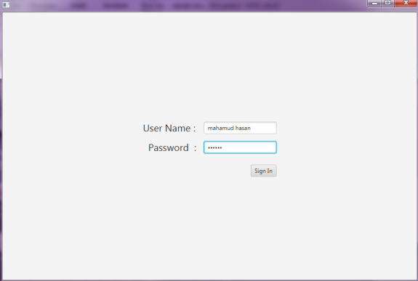

Insert value through the admin into database. It happens one by one insertion.

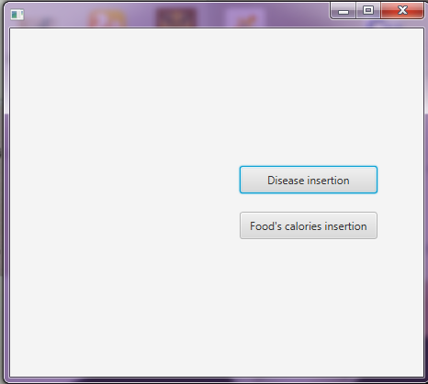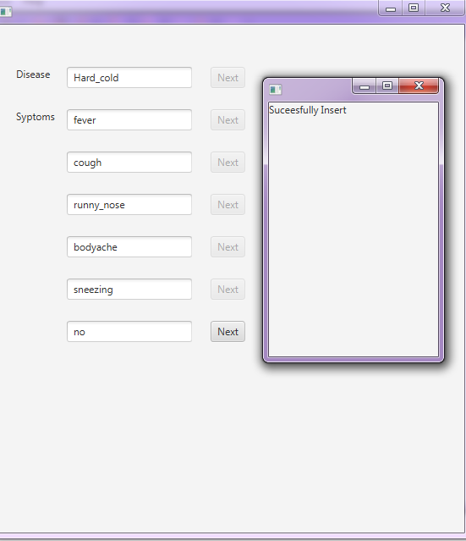

Any user can know his/her BMR in this software. To calculate BMR, there are some law. Man and women are different BMR. So It is very important to classify two laws in code.

|  |
| --- |
| **Metric BMR Formula** |
| **Women**: BMR = 655 + ( 9.6 x weight in kilos ) + ( 1.8 x height in cm ) - ( 4.7 x age in years ) **Men**: BMR = 66 + ( 13.7 x weight in kilos ) + ( 5 x height in cm ) - ( 6.8 x age in years ) |

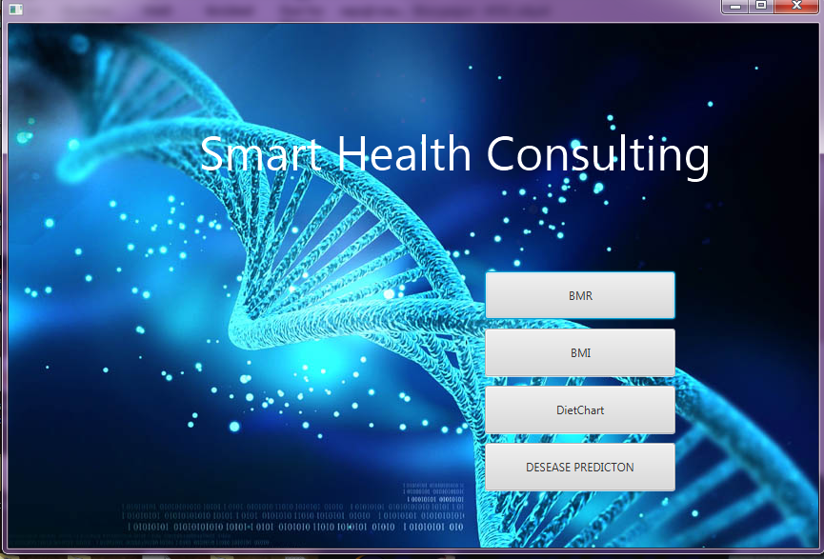

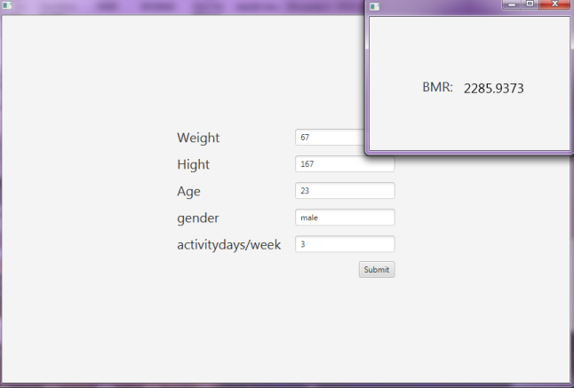

A user also can calculate his/her BMI.

|  |
| --- |
| **Metric BMI Formula** |
| BMI = ( Weight in Kilograms / ( Height in Meters x Height in Meters ) ) |

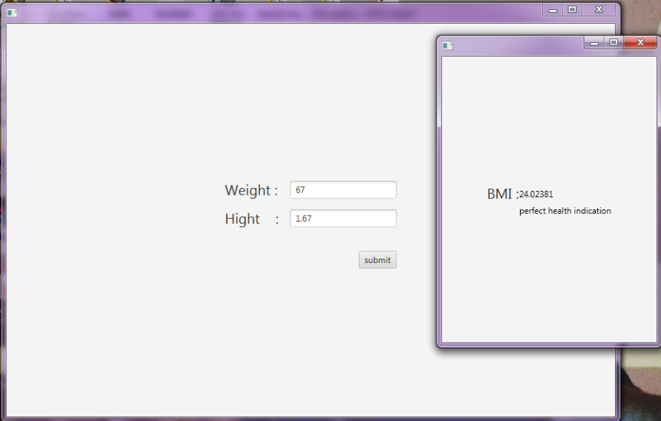

This system provides a diet chart so that any user can take proper daily calories. But to know about his/her diet chart , first he knows his BMR. He inserts his BMR and get it.

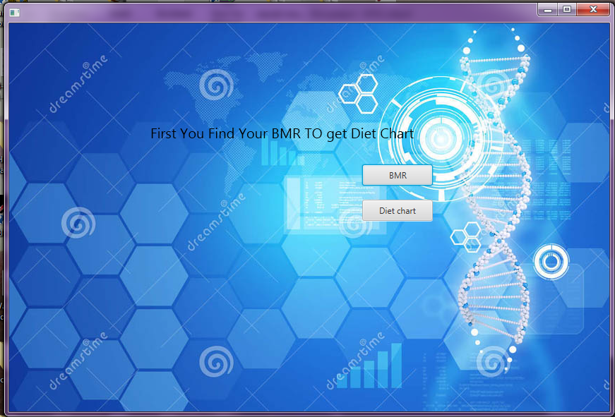

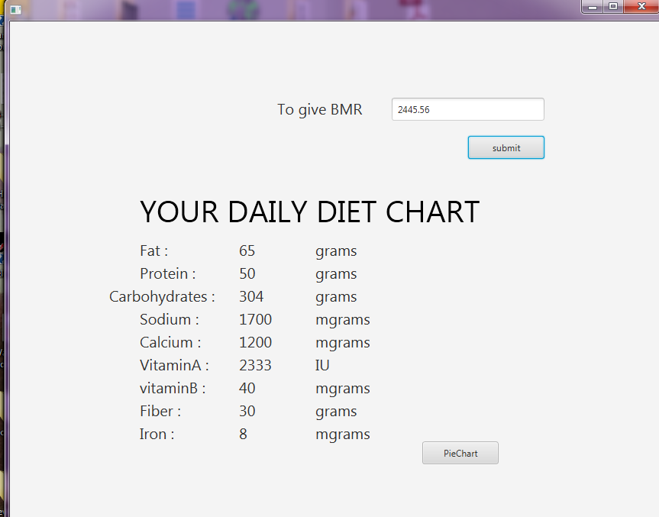

Here a pie chart for a user to easily understand about his /her diet chart.

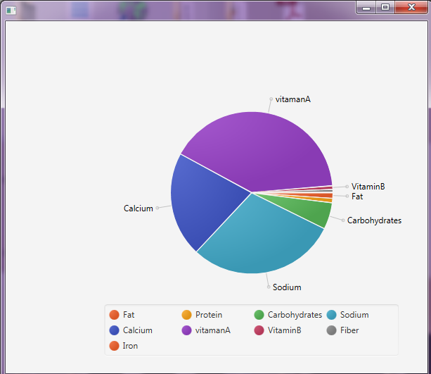

The system is fed with various symptoms and the disease/illness associated with those systems. The system allows user to share their symptoms and issues. It then processes users symptoms to check for various illness that could be associated with it. Here I use some intelligent data mining techniques to guess the most accurate illness that could be associated with patient’s symptoms. If the system is not able to provide suitable results, it informs the user about the type of disease or disorder it feels user’s symptoms are associated with. If users symptoms do not exactly match any disease in the database, is shows the diseases user could probably have judging by his/her symptoms.

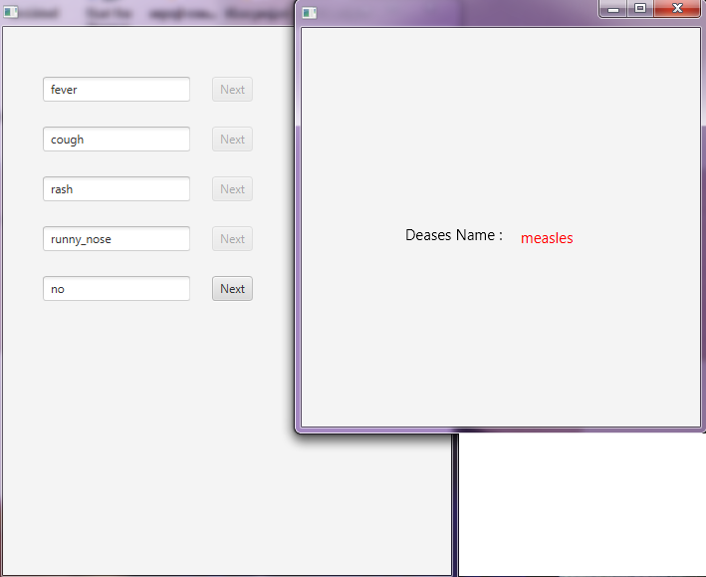

**How create and maintain Database:** To maintain the system to create database and maintain. I had created a database to store data. First making ER model based on the system.

Then make a database, I also make a database is named by disease1.

Then make various table. I create 8 tables for insertion disease and symptoms.

Then join the tables by different query to make table named by ‘firsttb’. And retrieve the data from the table.

**How to develop the system in future :** 1.The system can be developed to add Doctor’s consulting option.

2.The system can be developed based on intelligent data mining techniques to guess the most accurate illness that could be associated with patient’s symptoms.

3.The system can be developed to add diagnostic ability.

**Conclusion:**

This project involves in the course name of “software development project 2”

Under CSE 600.I am tried to my level best to make a useful project which helps to doctor and patient.